FINANCE- FINANCIAL CALCULATIONS Name___________________________________

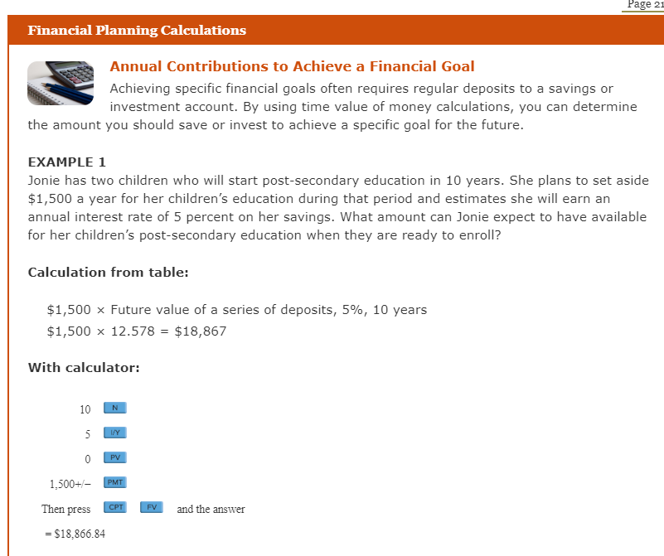

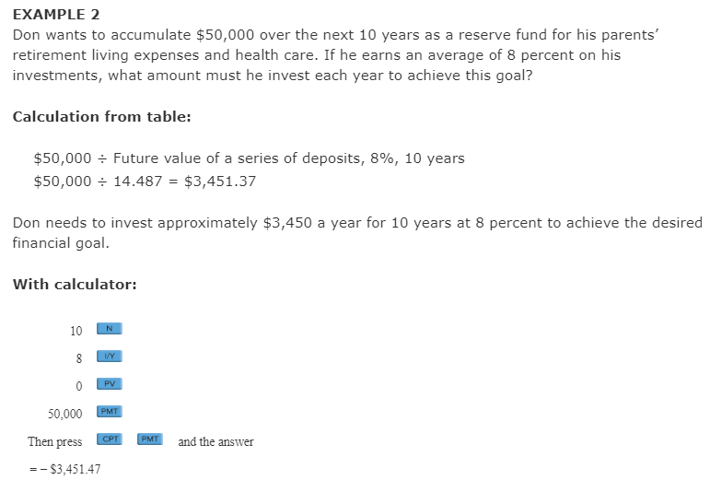

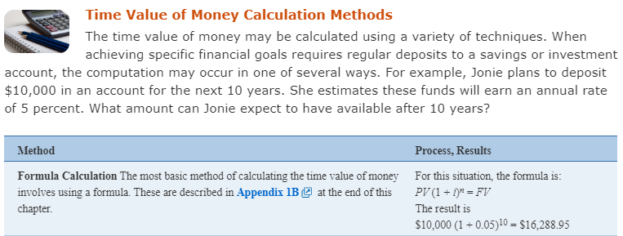

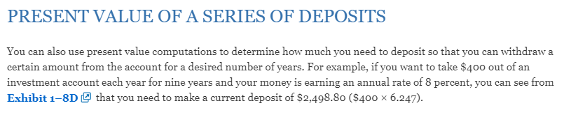

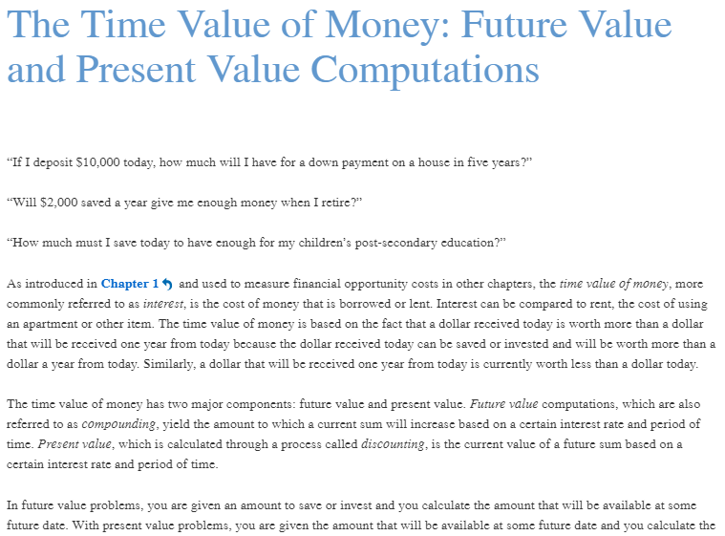
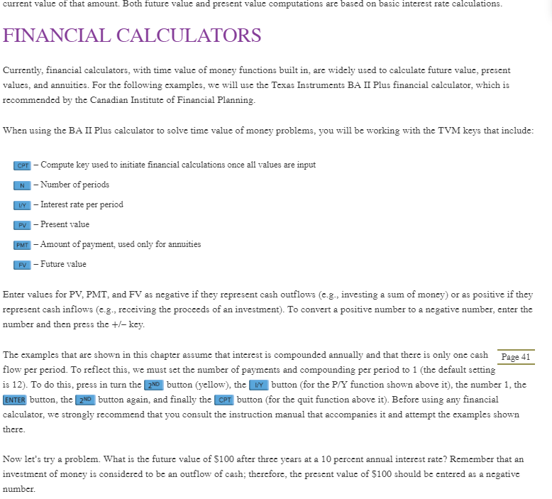

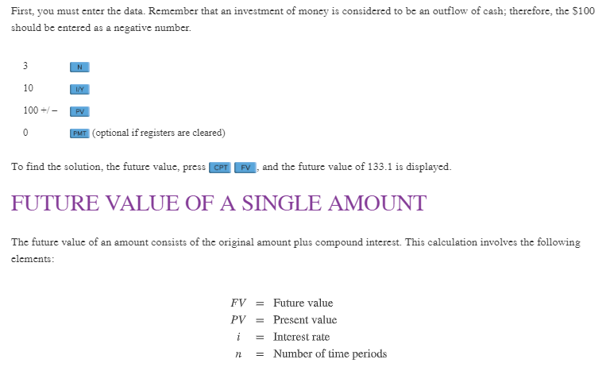

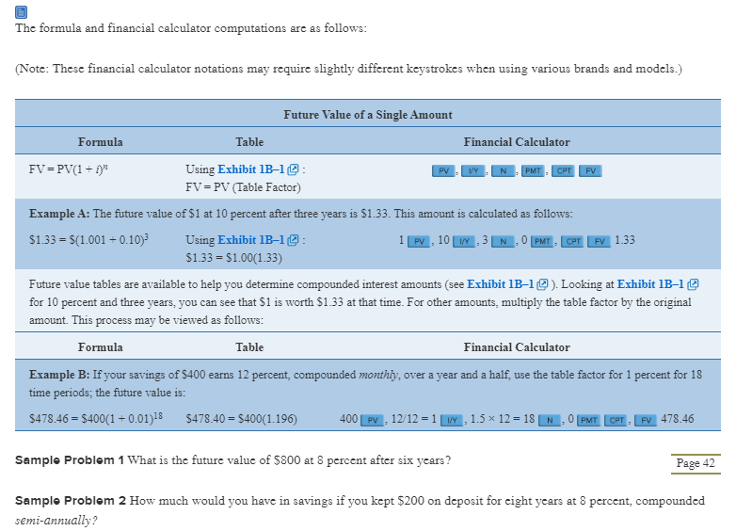

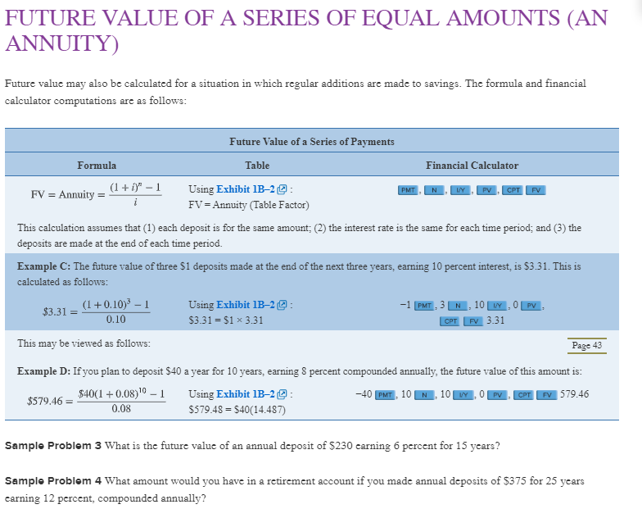
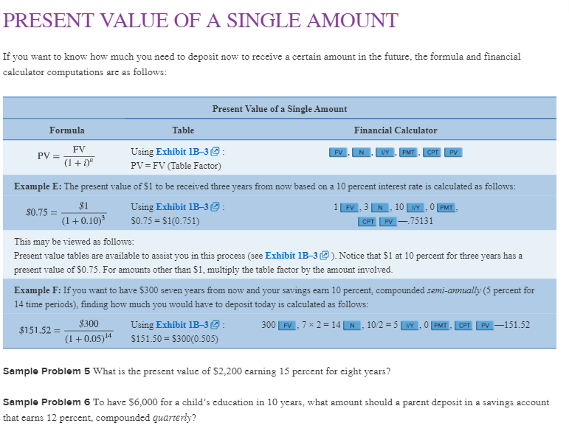

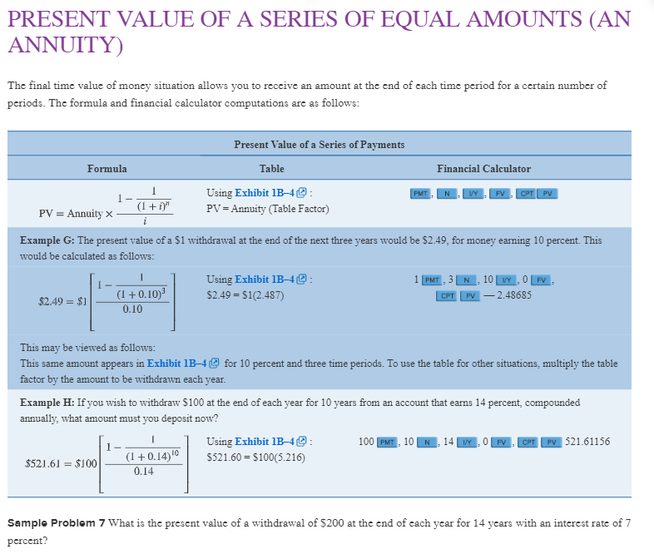
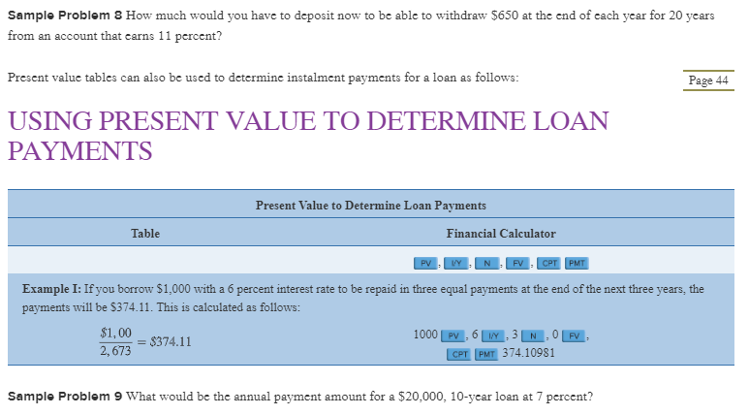
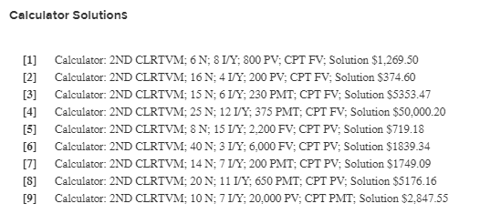
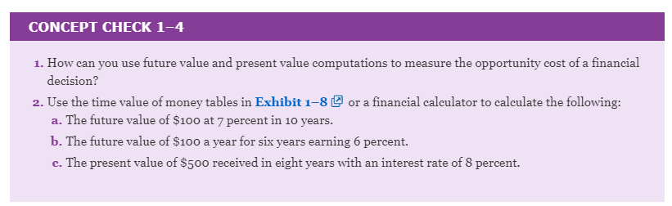

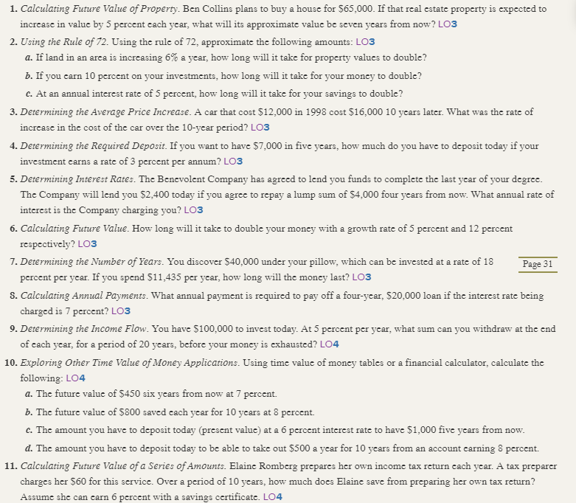
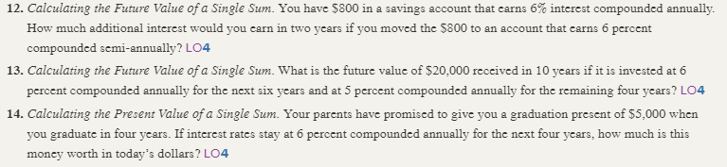

FINANCIAL PLANNING PROBLEMS key
(Note: Some of these problems require the use of the time value of money tables in Appendix 1B)
1. Ben Collins plans to buy a house for $65,000. If that real estate property is expected to increase in value by 5 percent each year, what will its approximate value be seven years from now?
$65,000 1.407 = $91,455
2. Using the rule of 72, approximate the following amounts:
a. If land in an area is increasing 6 percent a year, how long will it take for property values to double?
About 12 years (72 / 6)
b. If you earn 10 percent on your investments, how long will it take for your money to double?
About 7.2 years (72 / 10)
c. At an annual interest rate of 5 percent, how long will it take for your savings to double?
About 14.4 years (72 / 5)
3. In 1998, selected automobiles had an average cost of $12,000. The average cost of those same motor vehicles 10 years later is $16,000. What was the rate of increase for these items between the two time periods?
($16,000 - $12,000) / $12,000 = .3333 (33.33 percent)
4. How much should you deposit today to have $7,000 in five years if your investment earns a rate of 3% per annum?
7000/(1.03)⁵ = $6,038.26
- The Benevolent Company has agreed to lend you funds to complete the last year of your degree. The Company will lend you $2,400 today, if you agree to repay a lump sum of $4,000 four years from now. What is the approximate annual rate of interest that Benevolent is charging you? (Obj. 3)

$2400 = 4000 (DF i%, 4);
Solution: I% = 14%

- How long will it take to double your money with a growth rate of 5 percent and 12 percent respectively? (Obj. 3)

  - 72/5 = 14.4 Years.
  - 72/12 = 6 Years.

- You discover $40,000 under your pillow, which can be invested at a rate of 18% per year. If you spend $11,435 per year, how long will the money last? (Obj. 3)

$40,000 = $11,435 (PVAF 18%, n)
or $40,000 = $11,435 x ((1-1/1.18^{n})/.18) and solve for n

Solution n= 6 years.

- What annual payment would be required to pay off a four year, $20,000 loan if the interest rate being charged is 7%? (Obj. 3)

Payments = [$20,000 / (PVAF 4, 7%)] = $20,000 / 3.387 = $5905

9. You have $100,000 to purchase a 20-year annuity at 5 percent. What will be the annual payment from the annuity?

$100,000 = Payment x PVA factor (Exhibit 1B-4) and Payment = $100,000 ÷ 12.462 = $8,024.

10. Using time value of money tables, calculate the following:
a. The future value of $450 six years from now at 7 percent.
$450 1.501 = $675.45
b. The future value of $800 saved each year for 10 years at 8 percent.
$800 14.487 = $11,589.60
c. The amount that a person would have to deposit today (present value) at a 6 percent interest rate in order to have $1,000 five years from now.
$1,000 .747 = $747
d. The amount that a person would have to deposit today in order to be able to take out $500 a year for 10 years from an account earning 8 percent.
$500 6.710 = $3,355
11. Elaine Romberg prepares her own income tax return each year. A tax preparer would charge her $60 for this service. Over a period of 10 years, how much does Elaine save from preparing her own tax return (assume that she earns 6 percent on a savings account)?
$60 13.181 = $790.86

12. You have $800 in a savings account which earns 6% interest compounded annually. How much additional interest would you earn in 2 years if you moved the $800 to an account which earns 6% compounded semi-annually?
Annual compounding $800 (1.06)² = $898.88
Semi-annual compounding $800 (1 + .06/2)^{2X2} = $900.41 Difference = $1.53

13. What is the future value of $20,000 received in 10 years if it is invested at 6% compounded annually for the next six years and at 5% compounded annually for the remaining four years?

FV = $20,000 (FV _{6, 6%})(FV _{4, 5%}) = $34,484.38

14. Your parents have promised to give you a graduation present of $5,000 when you graduate in four years. If interest rates stay at 6% compounded annually for the next four years, how much is this money worth in today’s dollars?

PV = $5,000 (0.792) = $3,960

MULTIPLE CHOICE. Choose the one alternative that best completes the statement or answers the question.
1) Assume your uncle will pay you $100 for each of the next two years and $200 in years 3 and these amounts will be paid at year end. Assume the interest rate is 10% for the first two years and 12% for the next two (years 3 and 4). What is your uncle's promise worth in today's dollars? (Round your answer) 1) _______

A) $600 B) $317 C) $512 D) $453 E) $342

2) What is the future value of $20,000 received today, after 10 years if it is invested at 6% compounded annually for the next six years and 5%, compounded semi-annually for the remaining four years? 2) _______

A) $32,772 B) $38,817 C) $25,000 D) $34,567 E) $31,000

3) What is the future value of $30,000 received today, after 10 years if it is invested at 7% compounded annually for the next seven years and 5%, compounded annually for the remaining three years? 3) _______

A) $71,000 B) $54,567 C) $81,744 D) $62,772 E) $55,767

4) What is the future value of $80,000 received today, after 14 years if it is invested at 8% compounded annually for the next five years and 3%, compounded annually for the remaining nine years? 4) _______

A) $171,022
B) $158,098
C) $153,371
D) $134,567
E) $144,772

5) If a person deposited $10,000 earning 9 percent for 11 years, this would involve what type of computation? 5) _______

A) present value of a single amount
B) simple interest
C) future value of a series of deposits
D) present value of a series of deposits
E) future value of a single amount

6) An individual invests $10,000 at a rate of 5% per annum. What will be its value in 10 years' time? 6) _______

A) $15,853 B) $15,000 C) $19,000 D) $18,000 E) $16,289

7) Your goal is to accumulate in 4 years $5,000. If you can earn a rate of 4%, compounded monthly, what will be your end of month monthly payment need to be to reach this goal? 7) _______

A) $124 B) $300 C) $104 D) $96 E) $262

8) Your goal is to pay down your student loan in 3 years. The balance today is $9,434. If you are charged a rate of 4%, compounded monthly, what will be your monthly, end-of-period payment? 8) _______

A) $279 B) $406 C) $300 D) $262 E) $377

9) An individual invests $5,000 at a rate of 5% per annum. What will be its value in 10 years' time? 9) _______

A) $9,000 B) $8,144 C) $9,542 D) $7,500 E) $7,927

10) Assume your friend will pay you $200 for each of the next two years and $400 in years 3 and these amounts will be paid at year end. Assume the interest rate is 10% for the first two years and 12% for the next two (years 3 and 4). What is your friend's promise worth in today's dollars? (Round your answer) 10) ______

A) $951 B) $831 C) $1,000 D) $906 E) $600

11) Your goal is to pay down your student loan in 3 years. The balance today is $9,434. If you are charged a rate of 9%, compounded monthly, what will be your monthly, end-of-period payment? 11) ______

A) $527 B) $406 C) $193 D) $300 E) $262

12) You wish to accumulate $15,000 within five years. How much would you have to save each year for five years to attain your goal? Assume an annual interest rate of 4%. Savings occur at the end of each year. 12) ______

A) $3,500 B) $2,662 C) $3,000 D) $2,905 E) $2,769

13) An individual invests $12,000 at a rate of 4% per annum. What will be its value in 9 years' time? 13) ______

A) $15,853 B) $15,000 C) $18,000 D) $17,080 E) $16,289

14) An individual invests $9,000 at a rate of 6% per annum. What will be its value in 11 years' time? 14) ______

A) $15,000 B) $17,085 C) $18,000 D) $16,289 E) $15,853

15) If a person deposited $100 a month for 5 years earning 9 percent, this would involve what type of computation? 15) ______

A) present value of a single amount
B) present value of a series of deposits
C) future value of a single amount
D) simple interest
E) future value of a series of deposits

1) D
2) D
3) B
4) D
5) E
6) E
7) D
8) A
9) B
10) D
11) D
12) E
13) D
14) B
15) E

